

**Campus Meal Ordering System**

**Release Plan**

**By Team Foodie**

**Lab Group: TS3**

**Date: October 2020**

**Instructors:**

**Bo An**

**Leong Yin Yoke Junie**

**Qiu Wei**

**Wang Rundong**

# SCHOOL OF COMPUTER SCIENCE AND ENGINEERING

**NANYANG TECHNOLOGICAL UNIVERSITY**

**APPROVALS**

**Submitting Organization’s Approving Authority:**

SCSE, NTU 6790 5786

Signature Printed Name Date Phone Number 

Nanyang Technological University



**Team Foodie’s Approving Authority:**

 MA XIAO 31/10/2020 93797588

Signature Printed Name Date Phone Number 

Project Manager



**REVISION HISTORY**

| **Version** | **Date** | **Organization/Point of Contact** | **Description of Changes** |
| --- | --- | --- | --- |
| 1.0 | 25/10/2020 | Team Foodie/Loh Yi Xuan Renice | Baseline Version |
|  |  |  |  |
|  |  |  |  |
|  |  |  |  |
|  |  |  |  |
|  |  |  |  |
|  |  |  |  |
|  |  |  |  |
|  |  |  |  |
|  |  |  |  |
|  |  |  |  |
|  |  |  |  |
|  |  |  |  |
|  |  |  |  |
|  |  |  |  |
|  |  |  |  |
|  |  |  |  |
|  |  |  |  |
|  |  |  |  |
|  |  |  |  |

**TABLE OF CONTENTS**

**1.** **INTRODUCTION 1**

**2.** **REFERENCED DOCUMENTS 1**

**3.** **OVERVIEW 1**

**4.** **ASSUMPTIONS, CONSTRAINTS, RISKS 2**

4.1. Assumptions 2

4.2. Constraints 2

4.3. Risks 2

**5.** **RELEASE APPROACH 2**

5.1. Rationale 2

5.2. Release Strategy 3

***5.2.1.*** ***Release Content*** *3*

***5.2.2.*** ***Release Schedule*** *3*

***5.2.3.*** ***Release Impacts*** *3*

***5.2.4.*** ***Release Notification*** *3*

**6.** **GLOSSARY 3**

**7.** **ACRONYMS 4**

**8.** **APPENDICES 4**

**LIST OF FIGURES**

Figure 1: Overview of CMOS Application...................................................................................2

Figure 2: Release Schedule……..................................................................................................6

**LIST OF TABLES**

Table 1: Referenced Documents...................................................................................................1

Table 2: Project Risks…………...................................................................................................3

Table 3: Risk Impact and Mitigation Strategies...........................................................................3



# INTRODUCTION

This release plan document applies to the CMOS application. In the release planning, the project manager and product owner create a long-term plan to deliver increments to the product and set the base by outlining the need, agenda, and key deliverables during each release. The release plan will be updated each time a new release version is tested, and the release content is verified to be working. The audiences of this release plan are the development team, test team, release team and relevant stakeholders of the CMOS Application. The purpose of the release plan are the following:

* **Road Map**: Create the release life cycle from the development to official release and future updates of the application.
* **Product Vision**: Extend visibility past a single sprint such that executives can make an informed budget and schedule decisions
* **Communication**: Allows stakeholders and project development team to understand the complete set of functionalities in a product
* **Documentation**: The release plan is used to record all related information for the application in its release life cycle.

Releases will be identified by major release, minor release, maintenance release and lastly, private hot fix (e.g. 4.1.1.100).



# REFERENCED DOCUMENTS

**Table 1: Referenced Documents**

| **Document Name** | **Document Number** | **Issuance Date** |
| --- | --- | --- |
| Project Proposal | Prerequisite Document | September 14, 2020 |
| Software Quality Assurance | Related Document | October 5, 2020 |
| Software Requirement Specification | Relevant Technical Documentation | October 5, 2020 |
| Project Plan | Prerequisite Document | October 19, 2020 |
| Risk Management | Related and Companion Document | October 19, 2020 |



# OVERVIEW

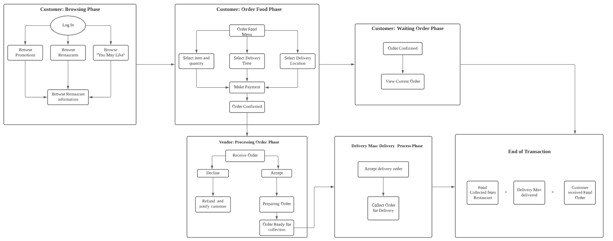

Figure 1: Overview of CMOS Application

The purpose of CMOS application is to provide a platform where staff and students can easily access food from Vendors in NTU campus and at the same time, for the Vendors in NTU campus to have more exposure and thus increase in customers. This is especially important in times of Covid-19 where physical interaction is reduced as much as possible.

The CMOS Application is divided into 3 users namely the Vendor, the Delivery Man and the Customer. Both the Vendor and Delivery Man has only 1 phase which is to accept or decline the order. On the other hand, the Customer is divided into 3 phases:

1. Browsing Phase
2. Order Food Phase
3. Waiting Order Phase

In the browsing phase, the Customer can browse Promotions, browse Restaurant list or browse “You May Like”. Promotions refers to restaurants having promotions. Restaurant list refers to the full restaurants available for food ordering. “You May Like” refers to the restaurants that the application uses an algorithm to suggest restaurants that the Customer most likely prefer based on previous orders. Lastly, in the Waiting Order Phase, the Customer can view the current order.

The transaction is ended when the Delivery Man collects the food order from the Vendor and the Customer receives his/her food order.



# ASSUMPTIONS, CONSTRAINTS, RISKS

## Assumptions

The composition of the team is not drastically affected by unforeseeable external circumstances or circumstances that may impact the release plan.

Indefinite support for the following technologies

* Flutter
* Android/iOS
* Firebase

## Constraints

The short development time is the main constraint of this project. Developers need to complete the project proposal and get approval before starting the project plan and requirement specification document for the system. To complete version 1 of the application within a short time frame of 1 month, team members were divided into smaller groups to perform the frontend and backend development and the relevant project documentation.

## Risks

**Table 2: Project Risk**

| **Risk** | **Description** |
| --- | --- |
| People Risk | Unable to recruit team members of required skills. Some team members are unavailable at critical times. |
| Development Environment Risk | Difficult to predict development environment changes due to advancement in technology. |
| Time Estimation Risk | Time required to develop software and/or time required to test and debug the software are underestimated. |
| Requirement Risk | The stakeholders may propose changes to the requirements which require major design changes as they fail to understand the impact of requirement changes. |
| Organisation Risk | Organisational problems force reduction in the project budget. |

**Table 3: Risk Impact and Mitigation Strategy**

| **Risk** | **Impact** | **Mitigation Strategy** |
| --- | --- | --- |
| People Risk | The project might lack behind if some team members are absent at a critical time. Difficult to recruit additional members with required skillset within such a short timespan and they may require more time to learn. | Organise the team such that there is more overlap of work so that the members understand each other’s job. Prevent any team member from having too much responsibility. |
| Development Environment Risk | CMOS may not be able to run on a new platform as expected or bugs may appear while using it. | The project should be designed for portability and maintainability. |
| Time Estimation Risk | The project might be delayed if the development team and/or testing team is unable to estimate development/testing time accurately. | Provide stricter time estimates for the development and testing time before starting time such that there is a buffer for unforeseeable setbacks. |
| Requirement Risk | The stakeholders may not understand the functionalities of the product despite stated requirements listed initially. | Communicate with stakeholders more to align and clarify misunderstandings with requirements early. |
| Organisation Risk | Quality of the project may drop, or the timeline of the project may be shortened. | Prepare a briefing document for senior management to show the importance of the project. |



# RELEASE APPROACH

## Rationale

The release approach will ensure that the complete application can be delivered to the end users with the requirements as planned initially. Before it is released to the stakeholders and end users, testing will be done. The design, implementation and testing phase will also have to follow the schedule strictly in order for the project to be carried out according to schedule.

## Release Strategy

The aim of the release strategy is to design a release plan and decide on release dates for the functionalities of CMOS. The critical and defining features such as the ordering system should be released in the first version and subsequent versions should provide less important features or updates which would enhance the users’ experience. Before each release, all functionalities will be tested by the test team.

### Release Content

**Table 4: Release Version**

| **Release Version** | **Functionality** |
| --- | --- |
| Version 1.0 | **Vendors**   * Can receive orders * Process Orders (Accept or decline orders)   **Users**   * Browse Restaurants * Select a restaurant * Order food (Select item, delivery time, delivery place etc.) * Make payment via Foodie Application * Browse Current Order   **Delivery Man**   * Change order delivery status (Accept delivery order, etc.) |

| Version 2.0 | **Users**   * Browse “You May Like” * Browse Promotions * Sort and/or Filter restaurant list   **Admin**   * View Business Analysis * View Order Summary |
| --- | --- |

### Release Schedule

**Figure 1: Release Schedule**

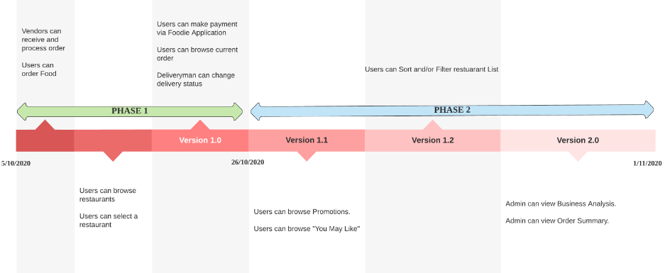

**Table 5: Release Schedule**

| **Release Version** | **Description** | **Start Date** | **End Date** |
| --- | --- | --- | --- |
| Version 1.0 | Phase 1 | 5/10/2020 | 26/10/2020 |
| Version 1.1 | Phase 2 | 26/10/2020 | 28/10/2020 |
| Version 1.2 | Phase 2 | 28/10/2020 | 29/10/2020 |
| Version 2.0 | Phase 2 | 29/10/2020 | 1/11/2020 |

### Release Impacts

Version 1 serves as a baseline of the application. The baseline versions are crucial to the clarifying requirements of the system as they will be the most used features and are the most defining features. The release version 1.0 is the official functional interface that will be shared with students and staff in NTU Campus to order food delivery. Subsequent releases will add features that will improve the coverage of functionality for the application. These features are less important than features in version 1.0 but will help to provide a complete and wholesome application. With version 2.0, the project should contain all functionalities that are essential in a Food Delivery Application.

### Release Notification

The version control platform for this application is GitHub. When implementation is done on a set of features, the code will be uploaded to the version control system. The test team will start to test the latest version and provide feedback to the development team. Relevant documentation on the release will be uploaded and team members will be notified by email. Each release version needs to be tested and tests have to pass 3 days before the official release date. All notifications to team members will include information about the release - version number, features added/modified, release date and the test results. After the official release notification, the end user will receive the new version release notification which will contain the release number, release date and features added or updated.



# GLOSSARY

**GitHub**

A software versioning and revision control system distributed as open source under Microsoft Corporation.



# ACRONYMS

**CMOS** Campus Meal Ordering System